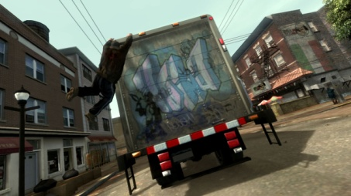 Welcome to GTA IV modding.

NOTICE – REPRODUCTION/REUPLOADING OR MAKING THIS GUIDE AVAILABLE FOR FREE IS PROHIBITED.

© GYPSYWIPSY – eBay.com.au

CONTENTS

- 1 – INSTALLING CAR MODS
- 2 – INSTALLING SOUND MODS
- 3 – INSTALLING GRAPHICS MODS
- 4 – UNLOCKING FILES
- 5 – GRAPHICS MOD TIPS
- 6 – PERFORMANCE TIPS

1 – Installing Car Mods
This section will cover installing car modifications for GTA IV PC. To download a car, visit www.gta4-mods.com and click the “Vehicles” tab. After that, you can browse the pages to find a car that you like.

STEP 1 – DOWNLOADING
After finding a car you like, click the “DOWNLOAD” button on the page.
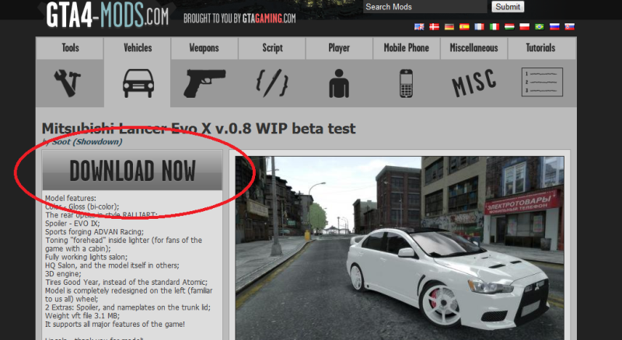
STEP 2 – Installing
Assuming you already have WinZip or WinRAR installed, you can open the .zip file and extract the car. The file extensions will end with .wtd and .wft. Extract them to the Desktop and open SparkIV.
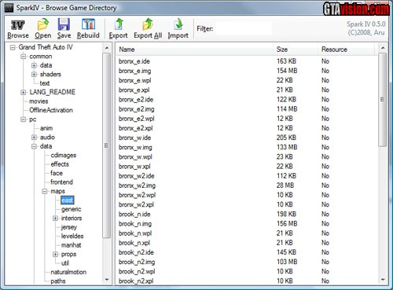
Navigate the sidebar on the left, all the way to the bottom until you see cdimages. Click it and on the right, you will see a file called vehicles.img. Open it.
Once opened, click “Import..” on SparkIV and find your car mod, open the .wtd and .wft file either one at a time or both at the one time, it doesn’t really matter.

STEP 3 – HANDLING
Now, going back to that archive you had open, there would be most commonly a text file called “Readme”. Open it and you will see two lines; one for the vehicles.dat file and one for the handling.dat file. Handling keeps the car from flipping on turns and Vehicles keeps the car from spawning without parts like bumpers, spoilers and extras, like liveries, vinyls and extras.

Highlight the line that has the vehicles/handling data in it and copy it, it looks like this

(CAR NAME HERE) 1400.0 2.00 85 0.0 0.1 -0.1 0.0 5 0.37 1.0 200.0 0.23 0.65 1.0 50.0 0.85 0.89 13.5 0.15 0.48 1.8 1.1 1.1 0.15 -0.14 0.0 0.50 1.0 1.0 0.8 1.1 1.5 0.0 14000 440000 0 0

Find the appropriate car name within vehicles.ide and handling.dat and replace them with the ones in the readme. Save and go, make sure you have deleted filelist.pak, that will ensure the changes to your handling and vehicles files stay changed.
There you go, you have now installed a car mod, you can now start GTA IV and play!

2 – Installing a Sound Mod

Installing sound mods is pretty much following the same procedure as installing a car mod, but we don’t have to change any data within the handling and vehicles files. Simply open SparkIV, browse the folder PC\AUDIO\SFX\STREAMED_VEHICLES.RPF, open it and import your custom sound and click “Save” before you close it. Note that this directory isn’t always where most sound mods are found, these are for car sound mods and a few others, refer to the mods “Readme” file before continuing.

3 – Installing Graphics Mods
This section will cover installing two types of mods, ENBSeries, which makes everything a bit brighter, certain versions add more bloom, change the sky cloud textures and reflections to stronger, more high definition ones. The second types are non-ENB, they are usually done through modding the file timecyc.dat, visualSettings.dat and visualSettings.xls. They change the way the game looks via lighting, sky colours and manipulating the weather and time.

INSTALLING ENBSERIES
OK, so you want to get the ENBSeries mod? Head over to www.enbdev.com and select the appropriate version for your needs, I recommend version 00.79 as it is most known to work well with most computers and trouble free.
NOTE THAT FOR ENBSERIES TO WORK, YOU MUST BE RUNNING PATCH 1.0.4.0

Once you have downloaded the version of ENB, extract all the files (excluding readme’s, licenses and keycodes) to GTA IV’s main directory
(C:\Program Files\Rockstar Games\Grand Theft Auto IV)
And run the game, you should notice the effect taking place as soon as the game starts, if the game doesn’t show any signs of improvement. Press SHIFT+F12.

INSTALLING TIMECYCLE MODS
A little harder than installing ENB, but still easy. You just have to drag and drop the timecyc.dat file into the file in GTA IV’s directory called pc\data and replace the file. visualSettings.dat and .xms files are located in common\data and replace the files. And you’re done!
Start the game, you will have to walk out of the safehouse to notice any difference in the sky/timecycle.

4 – Unlocking Files

In GTA IV, files need to be unlocked to be changed and modified. This process is extremely straight forward, works well and is guaranteed to work when done right.

STEP 1 – Set folder “Grand Theft Auto IV” to Non Read-only.

STEP 2 – Delete the file “filelist.pak” in pc\data

STEP 3 - Set folder “Common” to Non Read-only.

STEP 4 - Set folder “Data” to Non Read-only.

STEP 5 - Set folder “PC” to Non Read-only.

Set the executable (.exe file) “Grand Theft Auto IV” to “Run as Administrator”

Restart your computer and viola! You can now start modding text files in GTA IV.

5 – Graphics Mods Tips

Here are a few pointers when installing and looking to install a graphic mod on your game.

- Make sure you can run the unmodified version of the game smooth enough to modify graphics. As modifying graphics more often than not increases GTA IV’s hunger for system power.

- If you can barely run the game unmodified, don’t even waste your time trying ENBSeries. The amount of bloom, reflections and other fancy eye candy will reduce your PC to a low-FPS paperweight.

- (ATI ONLY) If you are noticing tearing in images after installing ENBSeries, you need to go into Catalyst Control Centre (CCC) and click the tab “Gaming” and then “3D Application Settings” and for Anti-Aliasing tick “Use application settings” same with “Anisotropic Filtering” and disable “Catalyst A.I” I know this works from personal experience.

6 – Performance Tips

Here are a few tips for you and GTA IV, hardware wise.

- Opt for the very latest in hardware. Excluding the six core processors, as no application will use six cores at once for a good 3-4 years now.

- Speedy memory. If your motherboard supports it; get DDR3. It’s better and faster than DDR2. No less than 4GB.

- Use a 64-bit operating system if you have more than 4GB of memory installed, if you don’t and you use a 32 bit operating system, Windows will only utilize and work with 3.5GB.

- SPEED not CAPACITY! – Opt for a fast, 1GB, DDR5 graphics card, forget the 2GB cards, you need a fast card to run GTA IV. Memory isn’t a problem – speed is.

Thanks for reading this tutorial, happy gaming!

-AussieProGamer/Gypsywipsy

